|  |
| --- |
|  |
| **GAME DEVELOPMENT I**  **MIDTERM**  **PROJECT REPORT** |
| TEAM 9- GATHER |
| Baran Avcı  121156048  Yıldız Elif Bolu  121156060 |
|  |
|  |

|  |
| --- |
|  |

**Table of Contents**

1. **Design History** 
   1. Ideation Process

1. **Game Overview**
   1. Game Concept
   2. Game Genre/Type
   3. Asset List
   4. Target Audience and Rationale
2. **Gameplay, Mechanics and Aesthetics**
   1. Gameplay
      1. *Objectives*
      2. *Play Flow*
      3. *Decision Tree/Flowchart*
         1. *Scripts*
            1. Room

Key-Mouse Input

InventoryInput

Camera

MouseLook

PlayerMovement

Transition

MoodboardTransition

PaintGameTransition

* + - * 1. Calendar

Calendar

* + - * 1. Notepad

ButtonControl

SaveLoad

* + - * 1. List

ChecklistManagerTut

ChecklistObjectTut

* + - * 1. Mood-board

FileBrowserUpdate

FirstMoodboard

SecondMoodboard

ThirsMoodboard

ForthMoodboard

* + - * 1. Paint Game

dotControl

PaintTry

toolSelecter

* 1. Mechanics
     1. *Movement*
     2. *Actions*
        1. *Calendar*
           1. Notepad
        2. *List*
        3. *Mood-board*
        4. *Painting Game*
  2. Aesthetics

1. **Level Design**
   1. Room
   2. Calendar
   3. Notepad
   4. List
   5. Paint Game
      1. *Paint Game (scene)*
   6. Mood-board
      1. *Mood-board (main scene)*
      2. *Mood-board (1)*
      3. *Mood-board (2)*
      4. *Mood-board (3)*
      5. *Mood-board (4)*
2. **References**
3. **Design History** 
   1. Ideation Process

* Useful for individual’s or groups’ scheduling
* Easy to schedule meetings and events

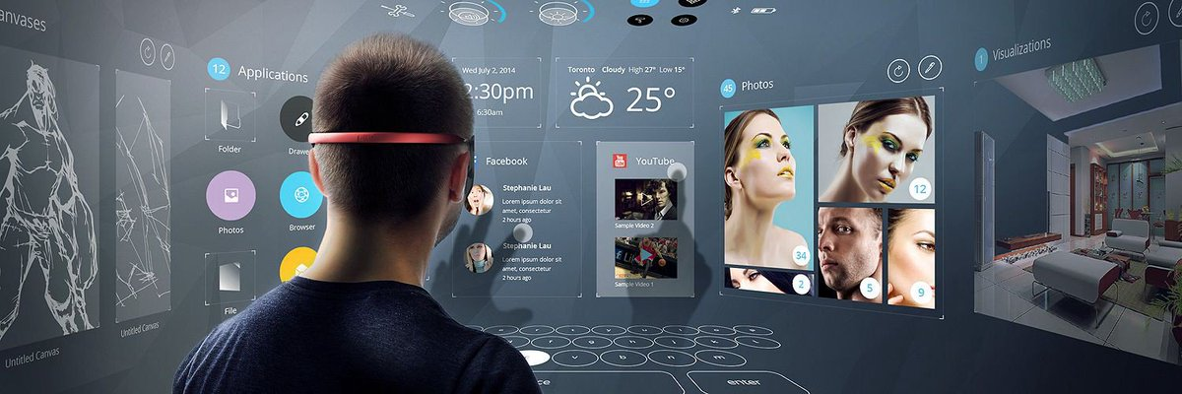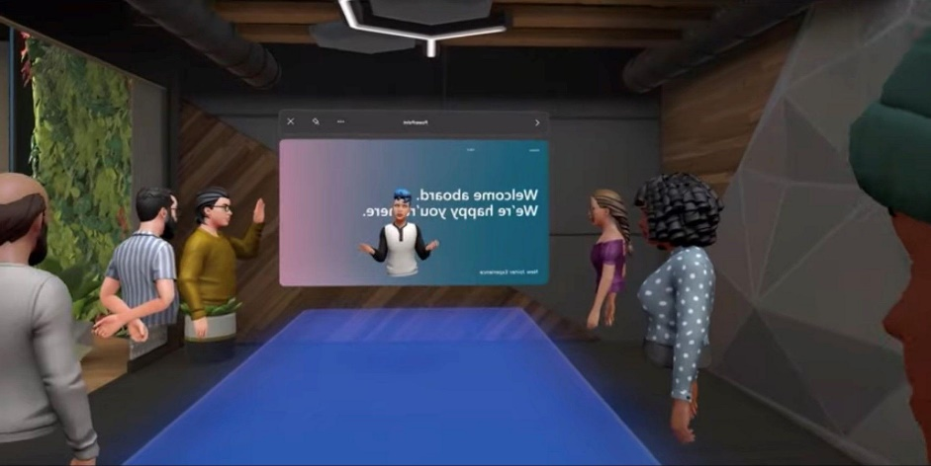

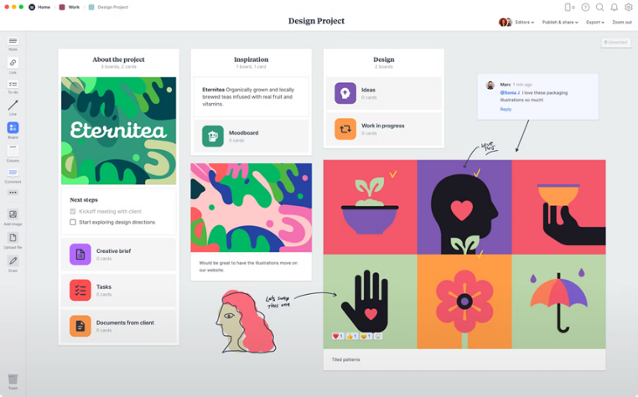

1. **Game Overview**
   1. Game Concept

Gather is a 3D meeting platform which is designed to use tools to organize the current meeting’s topics.

* 1. Game Type

First person interactive organizer platform.

* 1. Asset List
* Room
* Calendar
* Notepad
* List
* Mood-board
* Main board
* 1st board
* 2nd board
* 3rd board
* 4th board
* Painting Game
  1. Target Audience

Companies, schools, hospitals, everyone.

1. **Gameplay, Mechanics and Aesthetics**
   1. Gameplay
      1. *Objectives*

The objectives of Gather are it being simple and easy to use. The users can utilize; calendar and notepad to take notes and plan, list to record the things to do, mood-board to project the ideas into visual boards and painting game as clean board.

* + 1. *Play Flow*

Depending on the meetings flow the way that the room is used can change. While one taking notes others can create a mood board or everyone can only focus on one wall.

* + 1. *Decision Tree/Flowchart*
       1. *Scripts*
          1. Room

Key-Mouse Input

InventoryInput

InventoryInput script is being used on each four canvases in the room to open/close each one of them separately, which is being guided by the floor texts, and to make the mouse control visible.

Camera

MouseLook

MouseLook script descides on the sensitivity of the mose and gets the location of it according to the player.

PlayerMovement

PlayerMovement script gets the player location, descides on the speed, velocity and jump under the effect of gravity.

Transition

MoodboardTransition

MoodboardTransition script connects the room to the mood-board scene by loading the specific scene with scene manager.

PaintGameTransition

PaintGameTransition script connects the room to the paint game scene by loading the specific scene with scene manager.

* + - * 1. Calendar

Calendar

Calendar script updates the monthly colors of the existing days in a specific month. It consists of six weeks to show variations of 31 days in a month. It shows the current day as green and non-existing days as grey.

* + - * 1. Notepad

ButtonControl

ButtonControl script is linked to the clear button at the right bottom of the notepad panel. It takes the input and decides on if the text is going to be deleted or not.

SaveLoad

SaveLoad script is linked to the save button at the left bottom side of the notepad panel. It is connected to the text input and decides if the text will be saved or not.

* + - * 1. List

ChecklistManagerTut

ChecklistManagerTut script is linked to content that is being entered, add panel, create button and the item(s)/event(s) which is going to be assigned by the users. By JASON Data format the listed items are being collected and saved in the script.

ChecklistObjectTut

ChecklistObjectTut script is linked to checklist items. It collects the entered name and type of the items.

* + - * 1. Mood-board

FileBrowserUpdate

FileBrowserUpdate script takes place in every “Click To Add IMG” buttons which are linked to user desktop. The script opens files and let the user choose an image to put.

FirstMoodboard

FirstMoodboard script connects the mood-board main scene to the first mood-board scene by loading the specific scene with scene manager.

SecondMoodboard

SecondMoodboard script connects the mood-board main scene to the second mood-board scene by loading the specific scene with scene manager.

ThirsMoodboard

ThirdMoodboard script connects the mood-board main scene to the third mood-board scene by loading the specific scene with scene manager.

ForthMoodboard

ForthMoodboard script connects the mood-board main scene to the fourth mood-board scene by loading the specific scene with scene manager.

* + - * 1. Paint Game

dotControl

dotControl script generates or erases the dots when the user wants to place one or delete one on the canvas.

PaintTry

PaintTry script is linked to the manager which connects the dots and the canvas when the user draws something with their mouse.

toolSelecter

toolSelecter script links the eraser button and pencil button to the canvas and lets the user choose which tool that they want to utilize.

* 1. Mechanics
     1. *Movement*

The players view with a first-person camera. They can move with “WASD” buttons or the arrows. To interact with the room, they must press the mentioned keys and use a mouse.

* + 1. *Actions*

To utilize all walls the users, have to interact the way the floor texts say. By pressing the buttons as it says the user’s mouse and the panels get activated so that the players can interact.

* + - 1. *Calendar*

Calendar shows the current year, month and day (as green). By using the arrows, the user can change the months and by clicking on the “ADD NOTE” button the calendar canvas turns into a Notepad which can be used as notebook.

* + - * 1. Notepad

In the notepad panel, users can take multiple lines of notes. If they do not like they can clear the notepad or if they want to record they can click on the save button. To exit and return to the calendar “X” button must be clicked.

* + - 1. *List*

List panel is a to do list generator that can be used to create lists that can be saved. To add an item or a task the users have to press “ADD” button on the right side of the panel first. After filling the details one must click “CREATE” button. The interface saves automatically. The main page is a vertical scroll view which can move my holding and moving. To delete the items, users must check the green boxes next to them.

* + - 1. *Mood-board*

Mood-board scene can be used to create boards to show a process, a brainstorm or how ever the user wants to utilize. There are additional 4 mood-boards and in each board there are places for images and notes. Depending on the need any image file can be added to the mood-boards.

* + - 1. *Painting Game*

Painting Game is basically an empty board that users can draw, take notes or even doodle depending on their needs. On the panel there are only two options eraser and a pen that imitates an old-school pencil.

* 1. Aesthetics

Gather focuses on an aesthetic of a naturalistic work environment. It makes the meetings more playful and task oriented. The vigorous colour coordination has been chosen so that it would not bore users nor distract. The main point of the aesthetic is to achieve the maximum attention potential of users.

1. **Level Design**
   1. A screenshot of a computer

      Description automatically generated with medium confidenceA screenshot of a computer

      Description automatically generated with medium confidenceRoom
   2. Graphical user interface, calendar

      Description automatically generatedCalendar
   3. Graphical user interface

      Description automatically generatedNotepad
   4. Timeline

      Description automatically generated with medium confidenceGraphical user interface

      Description automatically generatedList
   5. Graphical user interface

      Description automatically generatedPaint Game
      1. *Text

         Description automatically generatedPaint Game (scene)*
   6. A picture containing funnel chart

      Description automatically generatedMood-board
      1. *A screenshot of a computer

         Description automatically generated with medium confidenceMood-board (main scene)*
      2. *Diagram

         Description automatically generatedA picture containing graphical user interface

         Description automatically generatedMood-board (1)*
      3. *Mood-board (2)*
      4. *Diagram

         Description automatically generatedMood-board (3)*
      5. *A picture containing graphical user interface

         Description automatically generatedMood-board (4)*
2. **References**

* Accessing The File Explorer 2021 - (Works in Editor & Build). (n.d.). Www.youtube.com. Retrieved April 28, 2022, from <https://www.youtube.com/watch?v=Z1qT65GL-6Q&ab_channel=TheUltimateDeveloper>
* Brackeys. (2019). FIRST PERSON MOVEMENT in Unity - FPS Controller [YouTube Video]. In YouTube. <https://www.youtube.com/watch?v=_QajrabyTJc&ab_channel=Brackeys>
* NOTEPAD | HOW TO MAKE AN APP IN UNITY TUTORIAL #1 - APP INTRODUCTION. (n.d.). Www.youtube.com. <https://www.youtube.com/watch?v=K362yUU9vJk&ab_channel=JimmyVegas>
* Unity 2D Tutorial: ToDo List (Part 1). (n.d.). Www.youtube.com. Retrieved April 28, 2022, from <https://www.youtube.com/watch?v=k2uLdL1fe8c&ab_channel=ETADLab>
* Unity 2D Tutorial: Calendar. (n.d.). Www.youtube.com. <https://www.youtube.com/watch?v=cMwCZhZnE4k&ab_channel=ETADLab>